Stage 0: Explore data (read the slide)
Stage 1: Cleaning Dataset
Cleaning this dataset involves addressing the key issues identified: negative inventory, negative or extremely low gross margins (potential errors/outliers), and ensuring data consistency. Below is a Python script using pandas that performs these cleaning steps and exports the result to a new Excel file.
This script takes a conservative approach:
- Negative Inventory: Sets negative Inventory values to 0, as negative stock is usually an error.
- Extreme Negative Gross Margins: Flags or removes rows where Gross Margin is below a very low threshold ( -100), as these are likely data entry errors, especially when paired with low sales and high COGS.
- Re-check again
- Save to new excel file

Stage 2: Define 4 questions:
- Overall Performance & Efficiency: How did our overall operational efficiency, measured by Profit Margin (%), trend over 2020-2021, and where did we significantly over or underperform against our budgeted expectations?
Rationale: This sets the stage. It establishes the "big picture" health of the business and immediately highlights areas of major concern (significant budget variances) that warrant deeper investigation.
- Expense Efficiency: What is the relationship between our key operational expenses (Marketing and Total Expenses) and our output (Sales and Gross Margin), and are we spending optimally?
Rationale: This moves from "what" happened to "why" it happened. It analyzes the efficiency of spending. Does throwing more money at marketing or other expenses reliably generate more sales and profit, or are we seeing diminishing returns?
- Product & Category Analysis: Which specific product categories or individual products are the primary drivers of our operational inefficiencies (low margin, high expense ratio) or strengths (high margin, efficient spending)?
Rationale: This drills down from overall expenses to pinpoint exactly which parts of the product portfolio are causing the problems (or excelling). This moves the analysis from departmental (expenses) to a tangible, manageable level (products).
- Regional Operational Strategy: How do operational efficiencies and expense effectiveness vary by Region and Market Size, and what does this tell us about our regional strategy?
Rationale: This adds the crucial geographical and strategic dimension. It identifies if our operational inefficiencies are a universal problem or concentrated in specific types of markets (e.g., Major vs. Small, East vs. West), allowing for tailored, actionable recommendations for management.

Stage 3: Chart and Visualization
1. Overall Performance: Time-Series Line Chart (Dual Axis)
Purpose: To provide a high-level, intuitive view of performance against plan over time. It answers "Are we on track?" at a glance.
Why This Chart Works: Plotting two lines on a shared time axis is the most efficient way to compare actual performance to a benchmark (the budget) over time.
The business significantly underperformed against its profit margin goals for the year.
- Consistent Underperformance: For most of the year, the actual profit margin (blue line) failed to meet the budget target (orange line).
- Severe Q1 Problem: The performance was especially poor at the start of the year (January-February), with a steep drop to deeply negative margins.
- Brief Recovery: There was a period of improvement from May through July, where performance briefly met and slightly exceeded the budget.
- Year-End Crash: The most alarming issue is the massive drop in the last quarter (Q4), where actual profit margins fell drastically, ending the year far below budget and in negative territory.
In short: Performance was volatile and ultimately unsuccessful, with a catastrophic decline at the end of the year that wiped out any mid-year gains.

2. Expense Efficiency: Scatter Plot
Purpose: To analyze the correlation between an input (spending) and an output (profit). It answers "Is our spending effective?"
Why This Chart Works: It moves beyond time and shows a direct relationship. It's unparalleled for identifying outliers, clusters, and general trends (e.g., "the more we spend, the more we make" appears as an upward trend).
The overall performance is mixed, showing a wide range of efficiency across states and product types.
- The Goal: The ideal is to be in the top-left quadrant (high Gross Margin, low Marketing spend), indicating high efficiency.
- The Reality: While some states or products are very efficient (high return for low spend), others are likely inefficient (high spend for low return or low spend for low return).
In short: Performance varies significantly. Some areas are efficient, but overall expense efficiency is inconsistent and can be improved.

3. Product Analysis: Sorted Horizontal Bar Chart
Purpose: To rank and compare the performance of many items clearly. It answers "Which products are the best and worst performers?"
Why This Chart Works: Horizontal bars are easier to read and label than vertical bars when there are many categories. Sorting them instantly creates a ranking, making the "best" and "worst" impossible to ignore.
Key Observations
- Most Profitable: Tea is the clear leader in profitability.
- Least Profitable: Espresso and Herbal Tea have the lowest profit margins (around 27.53%), and they appear to be equally profitable.
- Mid-Tier Profitability: Coffee has the second-highest profit margin.
In short, the analysis shows a significant difference in profit margins across the product line, with Tea being the most lucrative and Espresso and Herbal Tea being the least.
This is showing that the US culture showing no fancy in Herbal Tea at all.

4. Regional Strategy: Symbol Map + Bar Chart Dashboard
Purpose: To add a spatial and strategic dimension to the analysis. It answers "Where are our operations efficient or inefficient?"
Why This Works: A map is intuitive for location-based data. A bar chart next to it aggregates the data by a key business dimension (Market Size), allowing for clear "apples-to-apples" comparisons between types of markets.
Key Observations
- Highest Profit Margins: States colored in the darkest blue, such as New York, Texas, Washington, and Illinois, have the highest profit margins, which approach the top of the range at 47.17%.
- Lowest Profit Margins: States with the lightest coloring, like Colorado and Arizona, have the lowest profit margins, closer to the 6.64% end of the scale.
- Geographic Distribution: High profitability is not concentrated in one area. There are strong performers on the West Coast (Washington), the South (Texas), the Midwest (Illinois), and the Northeast (New York).
- Missing Data: A number of states, primarily in the Mountain West and Midwest (e.g., Montana, Wyoming, the Dakotas), are grayed out, indicating that there is no data available for them.
Stage 4: Dashboard
In dashboard we can filter product type to see how the data represents into each chart. For example, I filter “Tea”
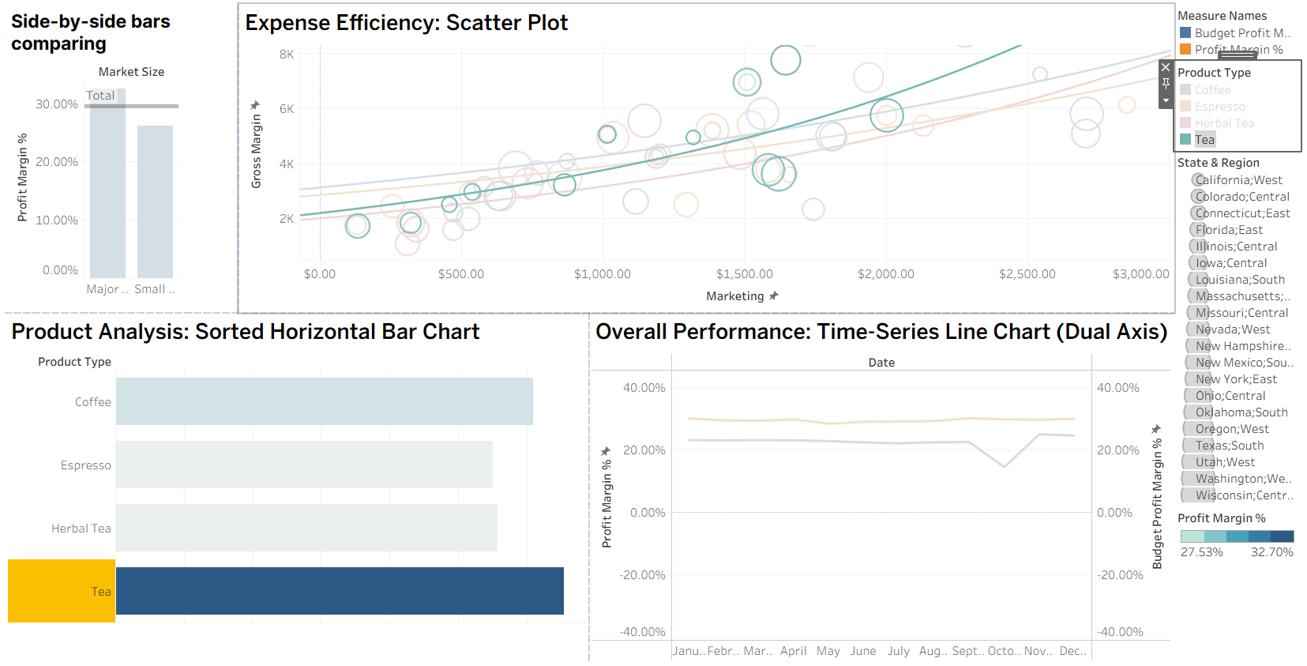
The company is consistently failing to meet its budgeted profit margin goals, with a noticeable dip in performance in the later months of the year.
However, the key to solving this problem might be sitting right in their product lineup. The data clearly shows that Tea is by far the most profitable product, significantly outperforming Coffee, Espresso, and Herbal Tea.
Furthermore, the scatter plot suggests that marketing dollars spent on Tea are more efficient, yielding a higher gross margin compared to other products.
The insight is clear: to close the gap on its profitability goals, the company should double down on its star performer, Tea. By shifting focus and marketing resources to promote their most profitable product, they could lift overall performance and reverse the trend of missing their targets.

